**TauDEM 5.3**

**QUICK START GUIDE TO USING THE TAUDEM ARCGIS TOOLBOX**

**October 2015**

**David G. Tarboton**

**Nazmus Sazib**

**Pabitra Dash**

# QUICK START

## Purpose

The purpose of this document is to introduce Hydrologic Terrain Analysis in ArcGIS using the TauDEM toolbox. This guide is not intended to be comprehensive in documenting the use and functionality of TauDEM. Rather it is intended as a brief introduction to guide a reader through the initial steps of installing TauDEM obtaining data and running some of the more important functions required to delineate a stream network. Comprehensive documentation on the use of each TauDEM function is given in the online help that is part of the program (that will be introduced in this quick start guide) and is online in the TauDEM website <http://hydrology.usu.edu/taudem> in the Documentation section.

TauDEM (Terrain Analysis Using Digital Elevation Models) is a set of Digital Elevation Model (DEM) tools for the extraction and analysis of hydrologic information from topography as represented by a DEM. This is software developed at Utah State University (USU) for hydrologic digital elevation model analysis and watershed delineation and may be obtained from <http://hydrology.usu.edu/taudem/>.

In this guide, you will perform the following tasks:

* TauDEM Installation
* Basic Grid Analysis using TauDEM functions, including.
  + Pit Remove
  + D8 Flow Directions
  + D8 Contributing Area
  + Grid Network
  + D-Infinity flow direction
  + D-infinity Contributing Area
* Stream Network Analysis using TauDEM functions, including
  + Stream Definition by threshold
  + Move Outlets to Streams
  + Stream Reach and Watershed
  + Peuker Douglas
  + Peuker Douglas Stream Definition
* Specialized Grid Analysis using TauDEM functions, including
  + D-Infinity Distance Down
  + D-Infinity Distance Up
* Basic Grid Analysis using TauDEM functions, for geographic coordinate data including.
  + Pit Remove
  + D8 Flow Directions

The Cub River watershed draining to USGS streamflow gauge #100096000 located just north of Preston, Idaho is used as an example. The Eno River watershed located near Durham, North Carolina is also used as an example for the geographic coordinate data.

## Computer Requirements

To complete this guide, you will need to use ArcGIS 10.0 or higher and TauDEM 5.3. TauDEM 5.3 has the following dependencies that are installed when you install TauDEM.

* GDAL - Geospatial Data Abstraction Library from <http://www.gdal.org/>.
* Microsoft HPC Pack 2012 MS-MPI Redistributable Package for parallel processing.
* Microsoft Visual C++ run time libraries for 32 and 64 bit windows platforms.

The ArcGIS software should be installed on your computer prior to starting this quick start guide, but we detail the steps involved in installing TauDEM and MPI libraries.

# TauDEM 5.3 Installation

TauDEM 5.3 needs to be installed using the TauDEM530.exe program. This setup application can install TauDEM both on Windows 32-bit and 64-bit computers. Download this setup program from <http://hydrology.usu.edu/taudem/taudem5/downloads.html>.

TauDEM setup program will install the following applications and libraries:

* TauDEM version 5.3.
* GDAL 111 (MSVC 2010 Win64): *Only on 64 bit computers.*
* GDAL 111 (MSVC 2010): *Only on 32 bit computers.*
* Microsoft Visual C++ 2010 x64 Redistributable: *Only on x64 computers.*
* Microsoft Visual C++ 2010 x86 Redistributable: *Used on both 32 and 64 bit computers*.
* Microsoft HPC Pack 2012 MS-MPI Redistributable Package.

By default, TauDEM will be installed at C:\Program Files\TauDEM. GDAL related libraries will be installed at C:\GDAL. GDAL applications will be installed at C:\Program Files\GDAL. MS HPC Pack will be installed at C:\Program Files\Microsoft HPC Pack 2012. Path entries are added to these locations.

**NOTE**: If you have previously installed an earlier version of TauDEM you should uninstall it. You don’t need to uninstall other TauDEM dependencies.

**Procedure for Installing TauDEM:**

1. Run (double click) TauDEM530.exe. You will need to click through all the prompts agreeing to the licenses of the various components. At the prompt to install GDAL select Typical.

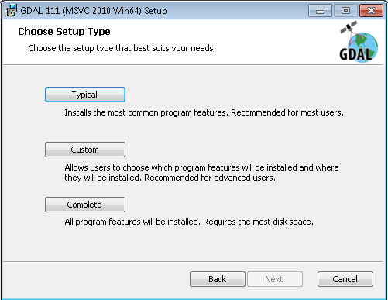

1. Eventually you get to click on “Finish” to finish installation of TauDEM. At this point you have successfully installed TauDEM 5.3.

Note that the redistributables libraries listed above that TauDEM depends on will only be installed if they are required for your platform and are not already installed. Note that the installer will also add firewall exceptions to allow TauDEM programs to run. These allow MPI interprocess communication used in the parallel computations. This is communication within your computer and not over any external network. The installer will also add the following path entries:

* C:\Program Files\Microsoft HPC Pack 2012\Bin\
* C:\GDAL
* C:\Program Files\GDAL
* C:\Program Files\TauDEM\TauDEM5Exe

The TauDEM Tools.tbx ArcGIS toolbox is included with the install and should work for ArcGIS 10.0 or higher (tested for versions 10.0, 10.2.2 and 10.3.1). Note that the installation does not require ArcGIS. Without ArcGIS you will be able to run all the functions from the command line, but will not be able to use the ArcGIS toolbox.

**Activate the TauDEM Toolbox in ArcGIS:**

* Open ArcMap/ArcCatalog. If the ArcToolbox Window is not open, click on the "Show/Hide ArcToolbox Window" icon in the Standard Toolbar.
* Right click on ArcToolbox at the top of the window. Select Add Toolbox.
* Browse to the TauDEM install directory (by default, this is: C:\Program Files\TauDEM\TauDEM5Arc).
* Click on the **TauDEM Tools.tbx** file, and click Open.

The TauDEM Toolbox should now be visible in the list of toolboxes.

**NOTE**: Activation of TauDEM ArcGIS Tools is only needed if you want to run TauDEM functionality from within ArcGIS.

The TauDEM Toolbox should now be visible in the list of toolboxes.

If you wish to save this configuration, right click on ArcToolbox, select Save to Default. This needs to be done for each user who wishes to use TauDEM. See below how we added TauDEM tools to Arc Toolbox:

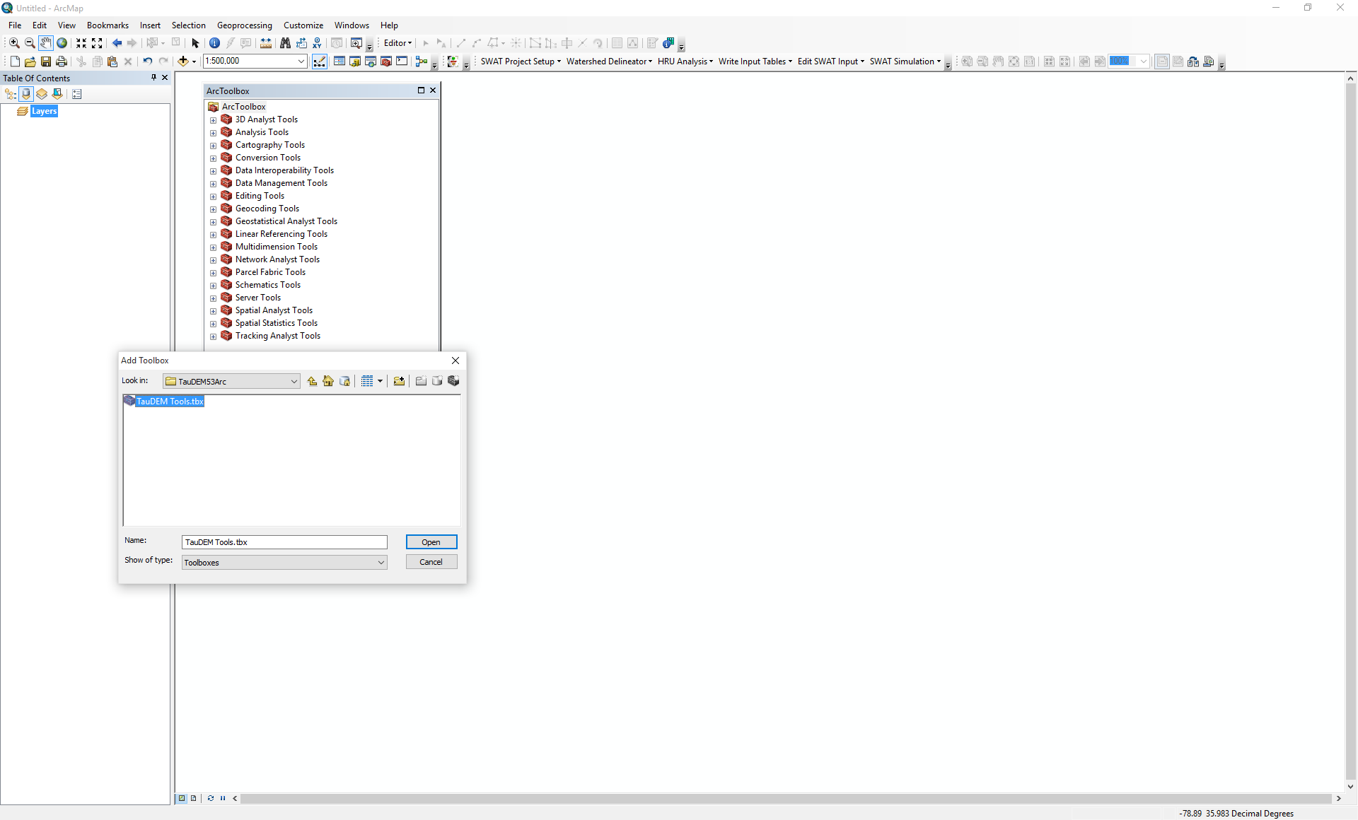

## Basic Grid Analysis using TauDEM functions

In this section we illustrate the TauDEM basic grid analysis functions. We start with a DEM in ESRI grid format and lead you through the steps of running the necessary TauDEM commands.

1. Download the Cub River example data zip file from the Documentation folder at <http://hydrology.usu.edu/taudem/>. Extract all files from the zip file and load cubdem into ArcMAP. This data was obtained from the National Elevation Dataset data server.

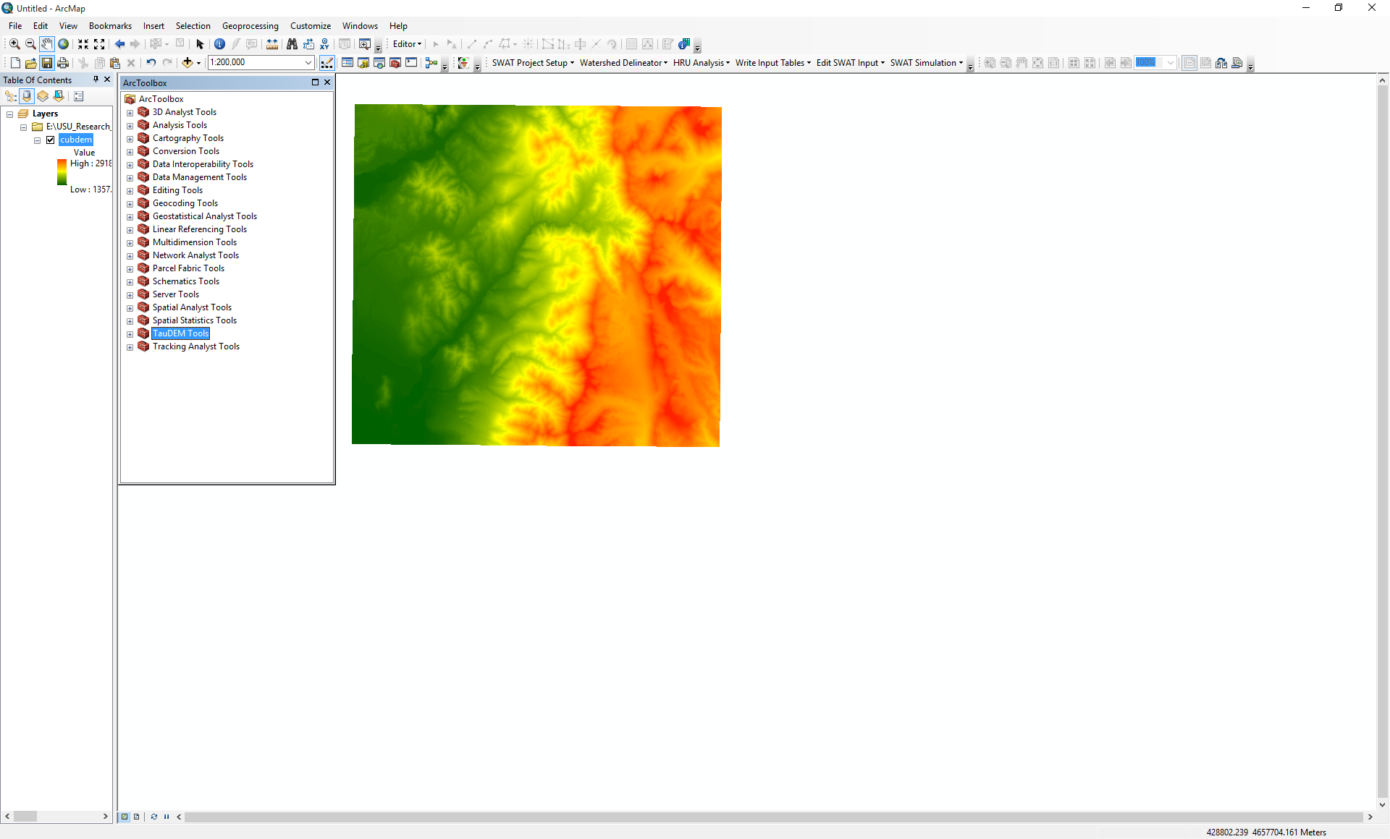

1. TauDEM 5.3 read all raster data that supported by GDAL (e.g. tiff, ESRI grid, and img) but writes in tiff format. The first TauDEM function used is **Pit Remove**. Pits are grid cells surrounded by higher terrain that do not drain. Pit Remove creates a hydrologically correct DEM by raising the elevation of pits to the point where they overflow their confining pour point and can drain to the edge of the domain. Open (by double clicking on) the TauDEM Pit Remove Tool (in the Basic Grid Analysis) set.

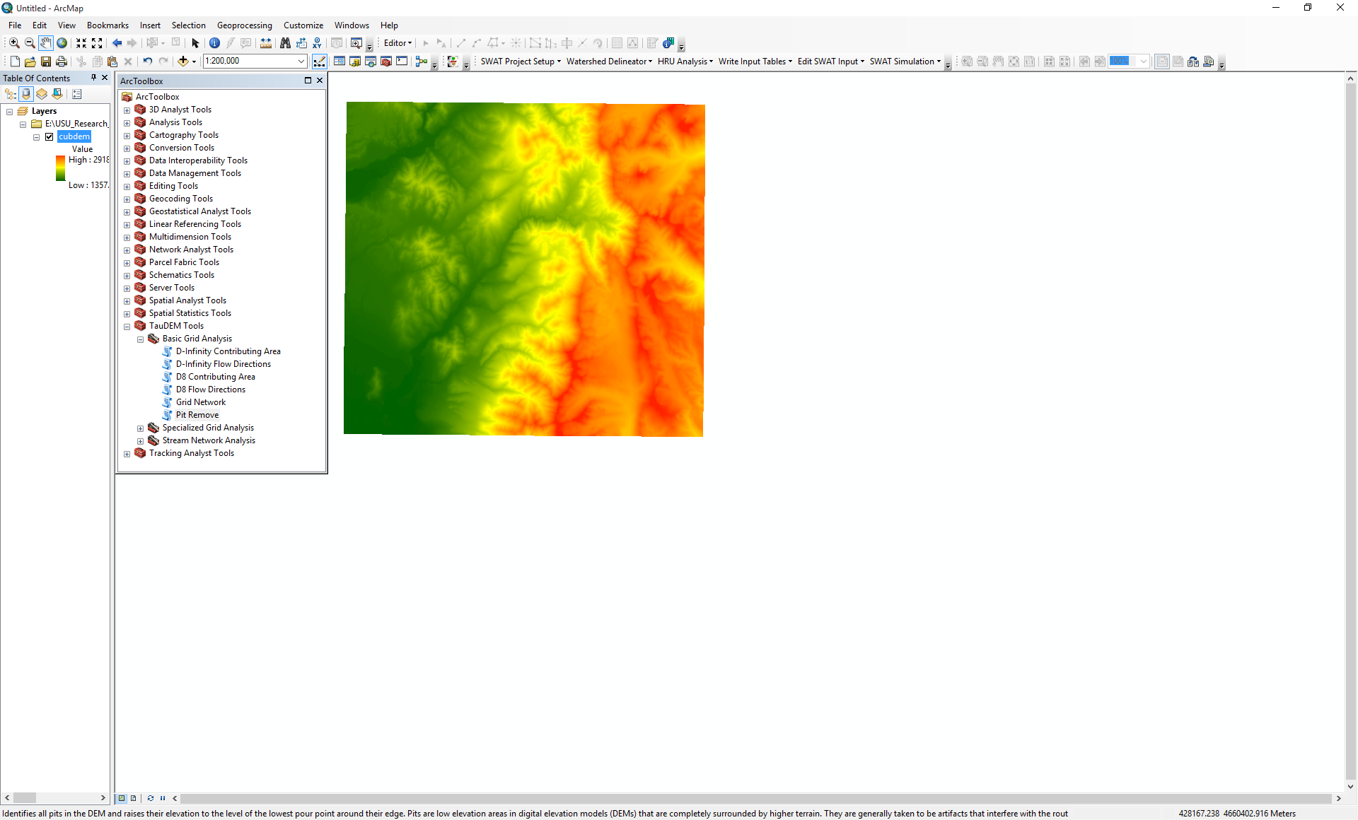

1. At the Pit Remove Tool dialog select Show Help to expand the embedded function help information.

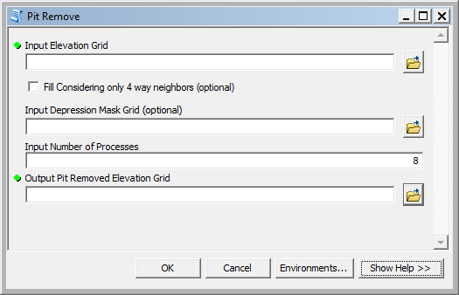

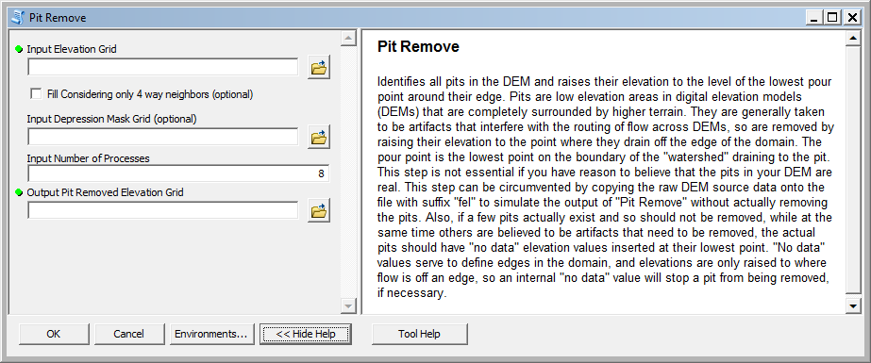

1. Click within each input field to obtain embedded context sensitive help for each input.

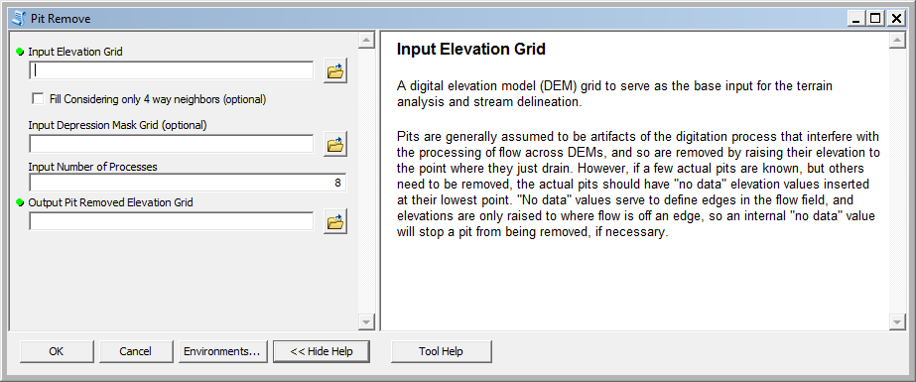

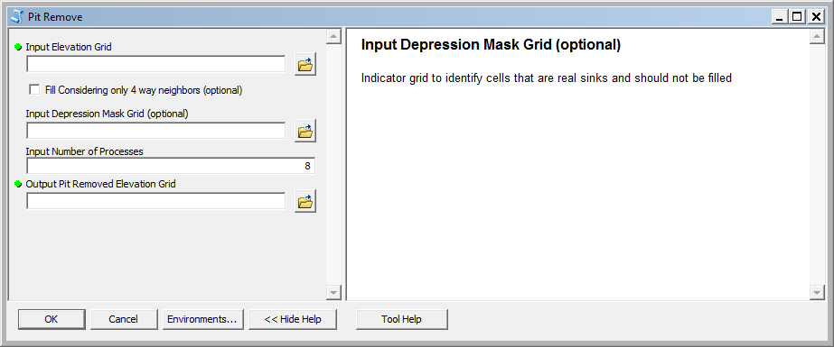

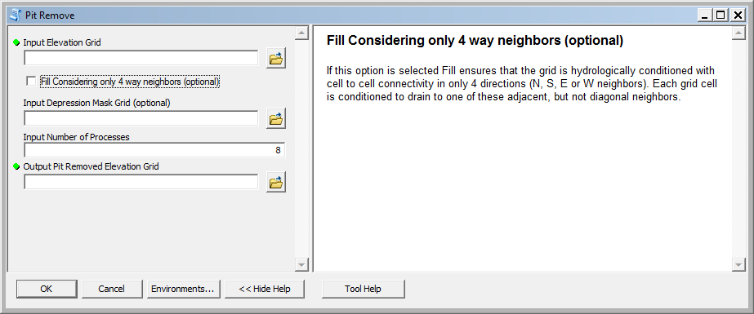

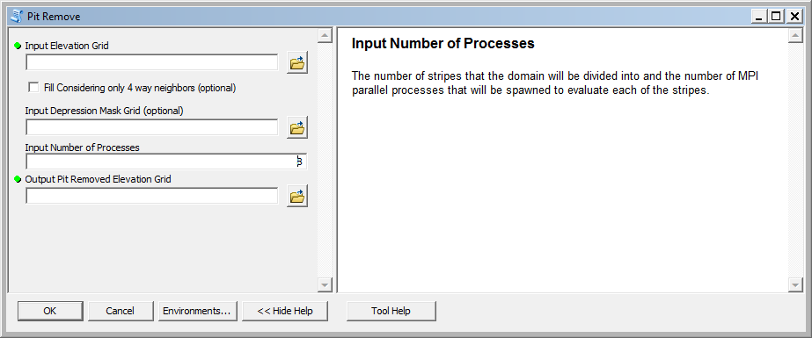

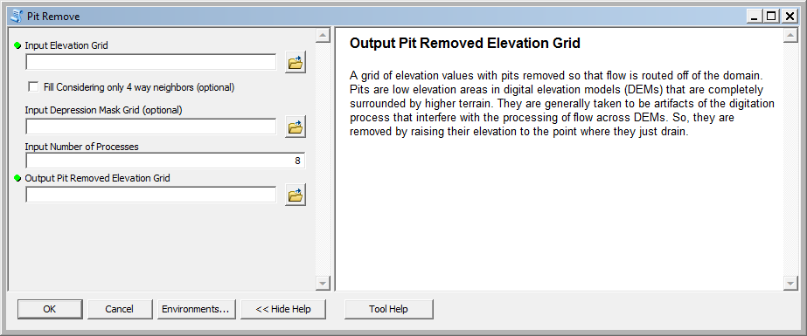

1. Click on Tool Help at the bottom to open the more detailed html help generated by ArcGIS for the Toolbox.

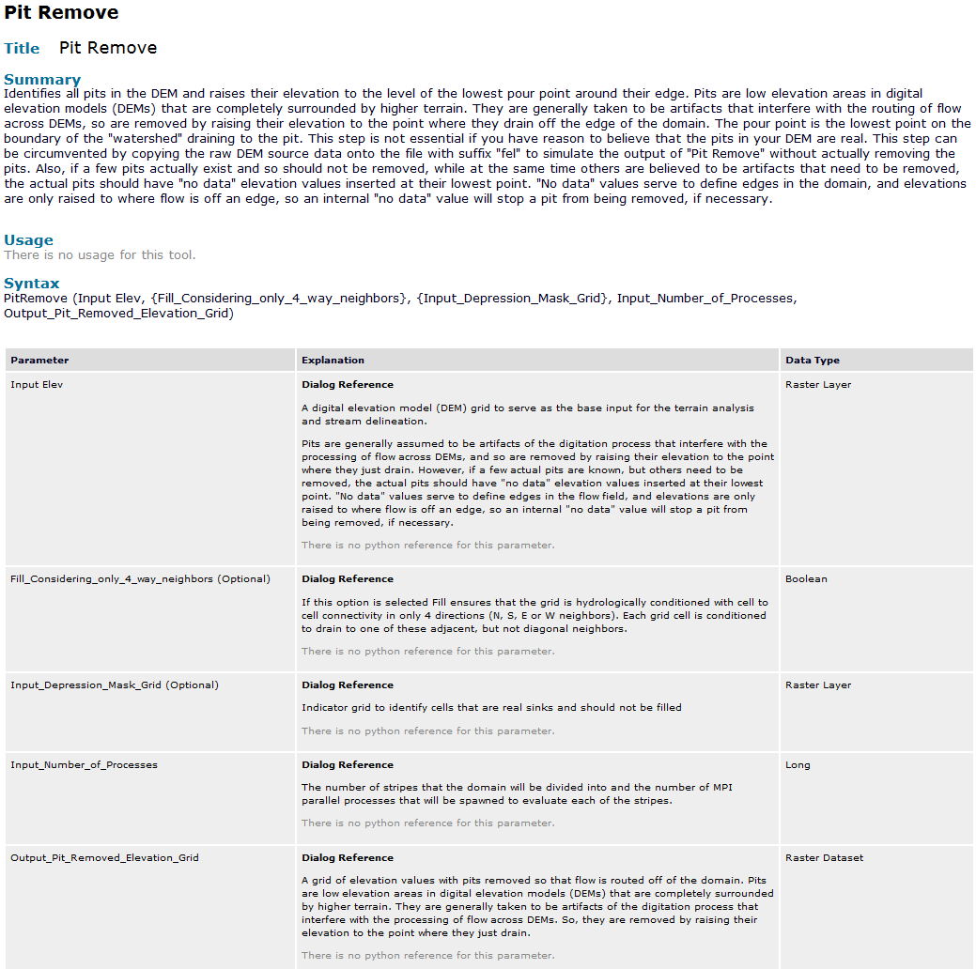

1. This TauDEM Documentation website contains an overview of the tools, data formats used and file naming conventions suggested for working with TauDEM. There is a detailed description of the functionality and parameters of each function. The tools are configured to, by default assign output file names following the naming convention given here. You do not have to use these names, but it is strongly recommended to aid in keeping track of the results.
2. Select **cubdem** for the Input Elevation Grid. Note that the Output Pit Removed Elevation Grid is automatically filled with cubdemfel.tif following the file naming convention. Select the Input Number of Processes (I used 8 for a dual quad core PC). Notice that input elevation (cubdem) is in ESRI grid but output Pitremove file (cubdemfel) is in tif format.

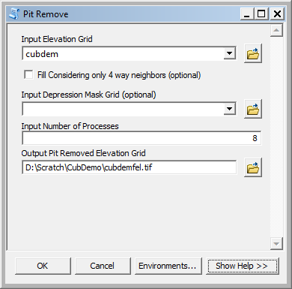

The parallel approach used by TauDEM is illustrated below. The domain is subdivided into row oriented partitions that are each processed independently by separate processes. When the algorithms reach a point where they can proceed no further within the partitions there is a swap step that exchanges information along the boundaries. The algorithms then proceed working within the partitions using new boundary information. This process is iterated until completion. The strategies for sharing information across boundaries and iterating are specific to each algorithm.

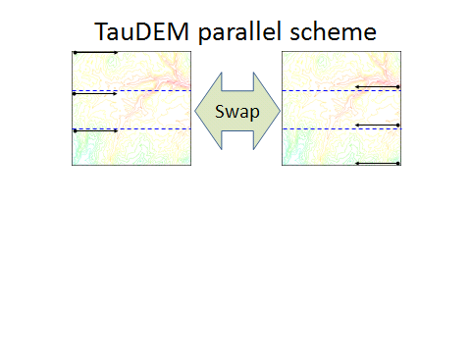

The number of processes does not have to be the same as the number of processors on your computer, although generally should be the same order of magnitude. The operating system (and MPI) takes care of time sharing between processes, so in cases where some processes are likely to be waiting for other processes to complete there may be a benefit in selecting more processes than physical processors on the computer. However, message passing across the borders are increased. For large datasets, some experimentation as to the number of processes that works best (fastest) is suggested.

1. Click OK on the Pit Remove tool to run the Pit Remove function for the cub river DEM. The output dialog reports run statistics that include timing, as well as any error or warning messages.

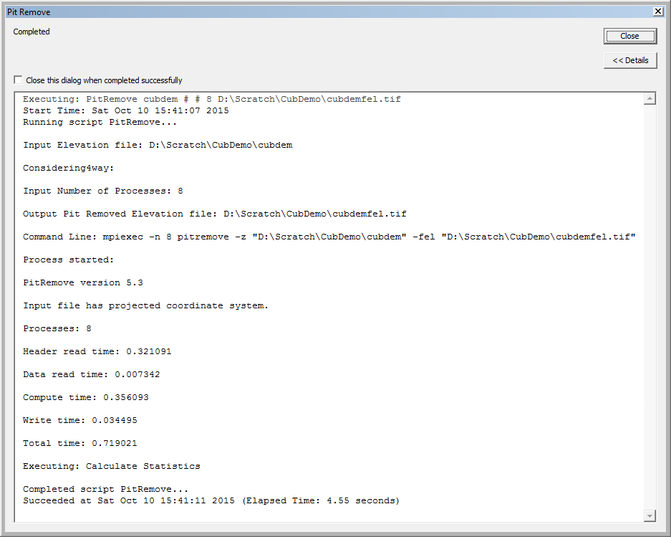

Note also in this output that timing information is reported for this run.

1. The next function to run is **D8 Flow Direction**. This takes as input the hydrologically correct elevation grid and outputs D8 flow direction and slope for each grid cell.

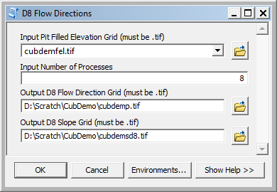

The resulting D8 flow direction grid (grid has suffix p) is illustrated. This is an encoding of the direction of steepest descent from each grid cell using the numbers 1 to 8. This is the simplest model of the direction water would flow over the terrain.

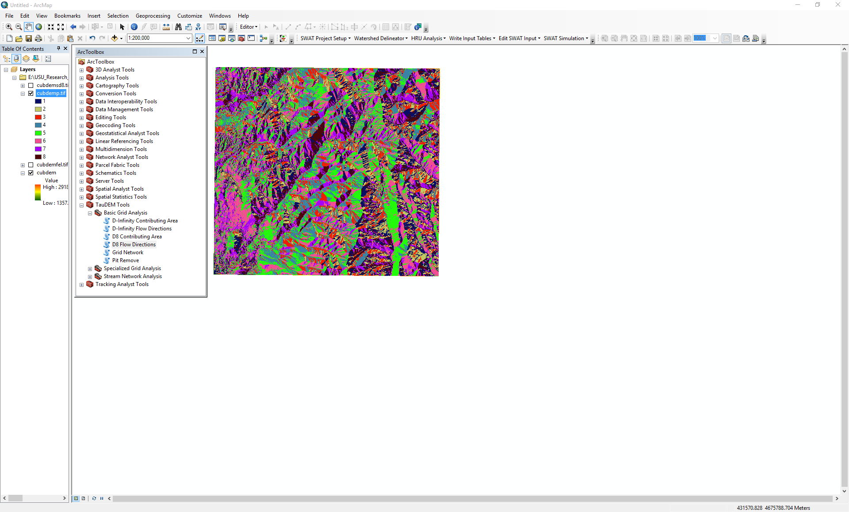

1. The next function to run is **D8 Contributing Area**. This count the number of grid cells draining through (out of) each grid cell based on D8 flow directions.

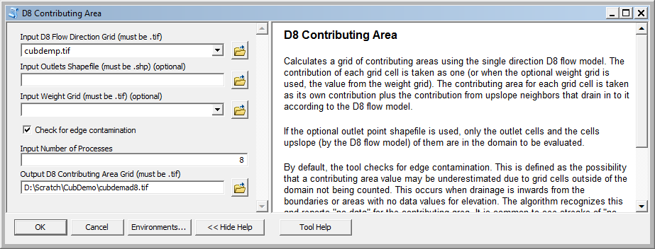

There are options to specify outlets and an input weight grid that were not used here. These are detailed in the tool help and allow calculations to be restricted to the area upstream of designated outlets (specified as a shapefile) and to accumulate an input weight field, rather than just counting contributing area as a number of grid cells. There is also an option to check for edge contamination. Edge contamination is a problem that can occur in the calculation of contributing area when flow is inwards from the boundary of the terrain. The computer does not know what the inflowing contributing area at the edge is, so evaluates the contributing area that may be impacted by this unknown area as no data. The result is streaks that enter the domain along flow paths. This is a desired result as it guards against missing parts of the watershed, but it can and should be turned off if the DEM has been clipped to a watershed boundary. A logarithmic scale is often best to render contributing area values as in the illustration below. Red has been used to display no data to illustrate edge contamination.

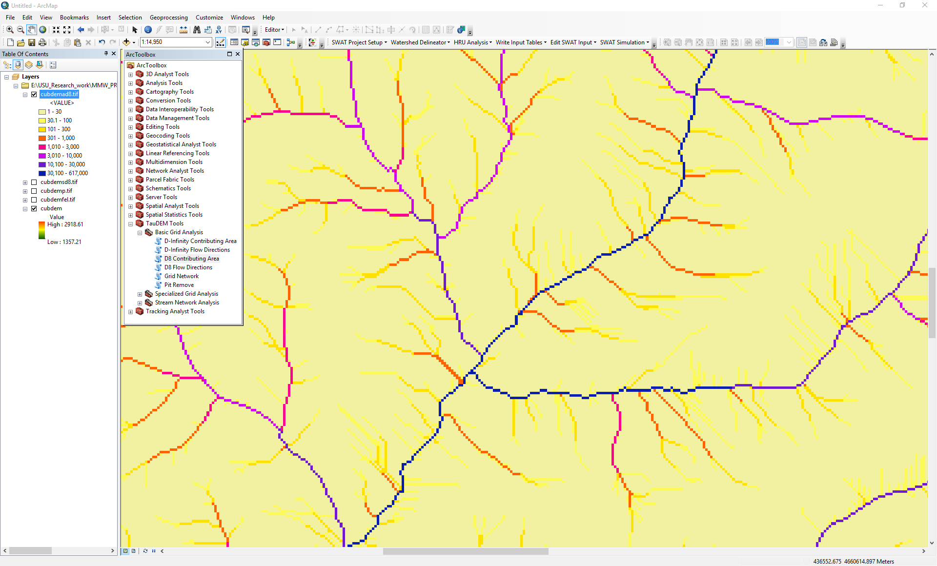

1. The **Grid Network** function outputs three grids: (1) the longest flow path along D8 flow directions to each grid cell, (2) the total length of all flow paths that end at each grid cell, and (3) the grid network order. This is obtained by applying the Strahler stream ordering system to the network defined starting at each grid cell.

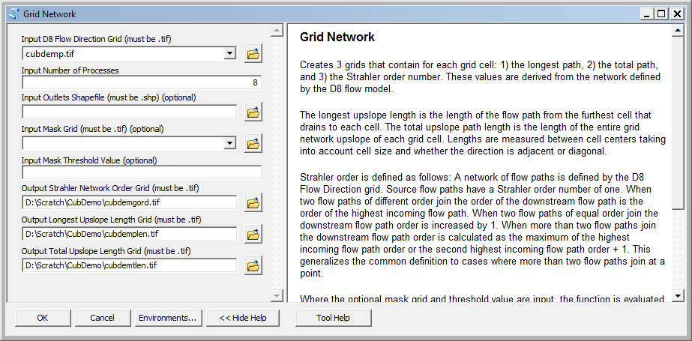

Grid Network Order (file name suffix gord) output from Grid Network is illustrated:

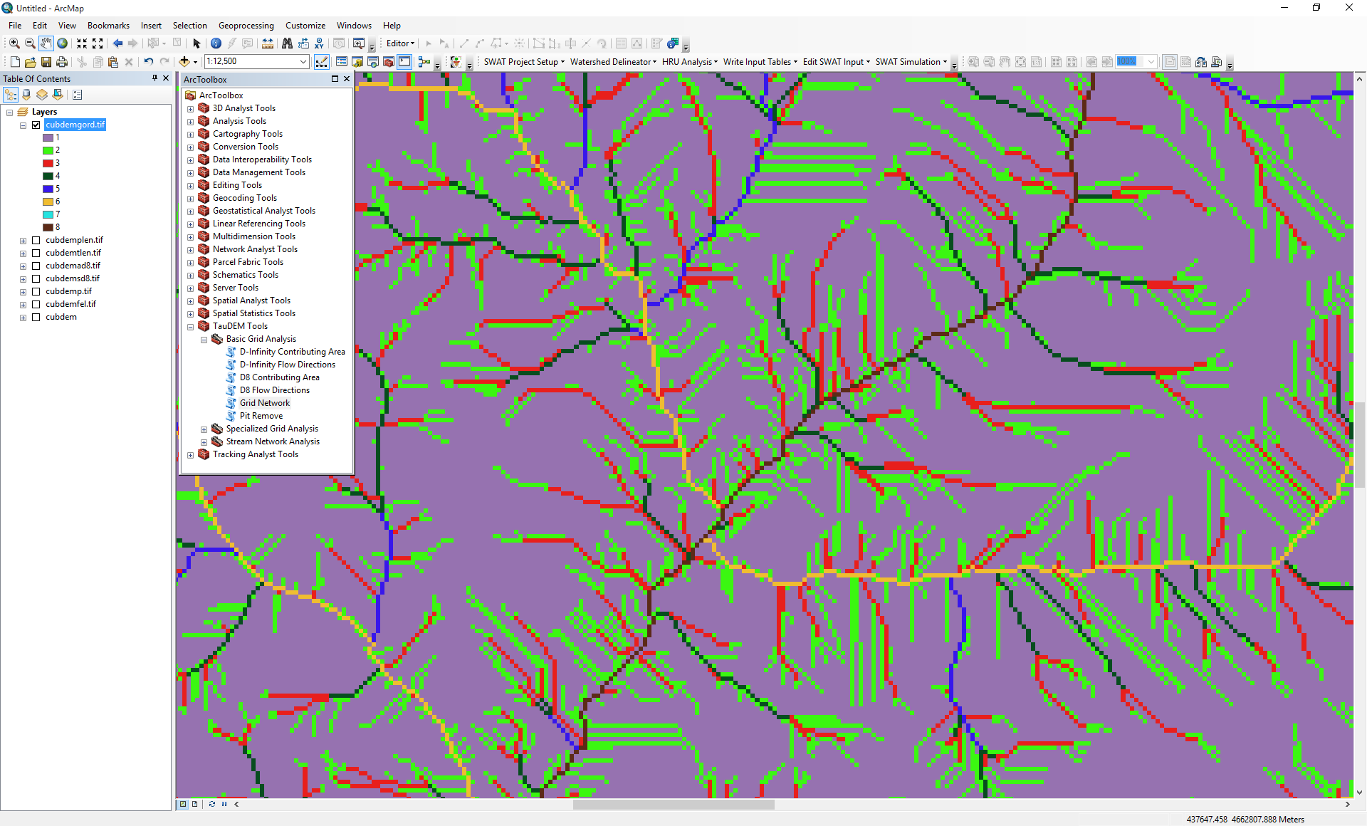

The functions above used the D8 flow model that represents flow from each grid cell to one neighbor. TauDEM also uses the D∞ (D-Infinity) flow model that calculates the steepest outwards flow direction using triangular facets centered on each grid cell and apportions flow between neighboring grid cells based on flow direction angles.

1. The **D-Infinity Flow Direction** function is starting point for all D-Infinity work. It calculates D-Infinity flow directions for use in other TauDEM functions requiring D-infinity flow direction input

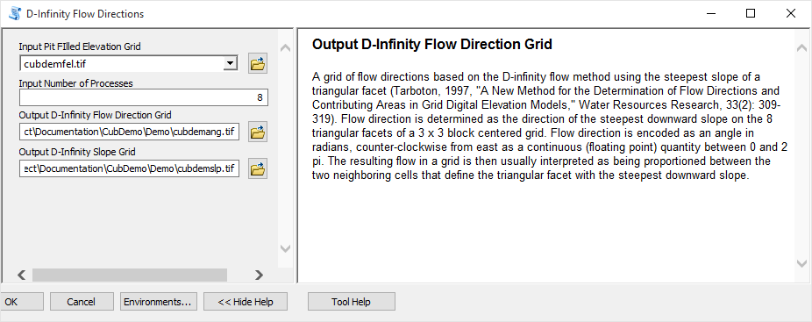

D-Infinity flow directions (encoded as angles counter clockwise from East in Radians) render similar to a hillshading.

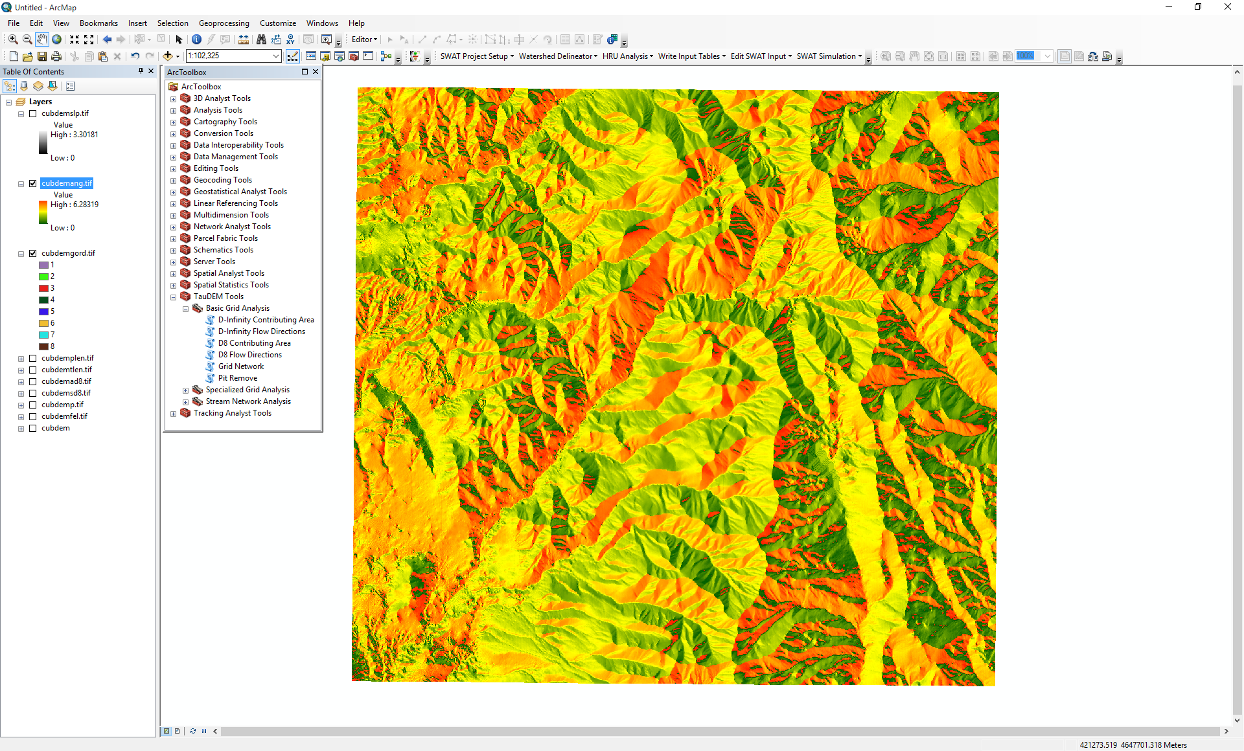

1. **The** **D-Infinity Contributing Area** function evaluates contributing area using the D-Infinity model based on flow being shared between grid cells proportional to the angle to the steepest downslope direction. This is designed to represent specific catchment area within dispersed flow over a smooth topographic surface.

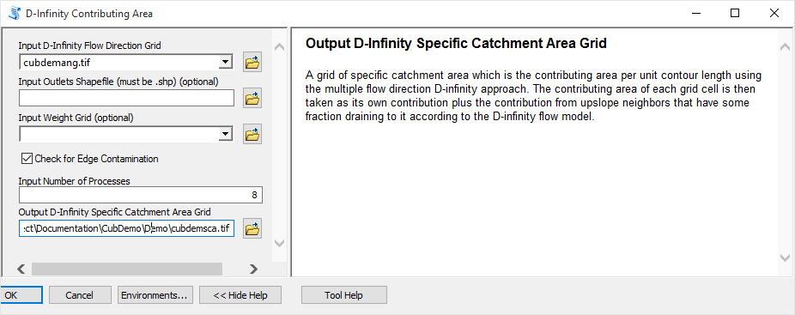

The result from running this is specific catchment area obtained from the D-Infinity contributing area function illustrated below

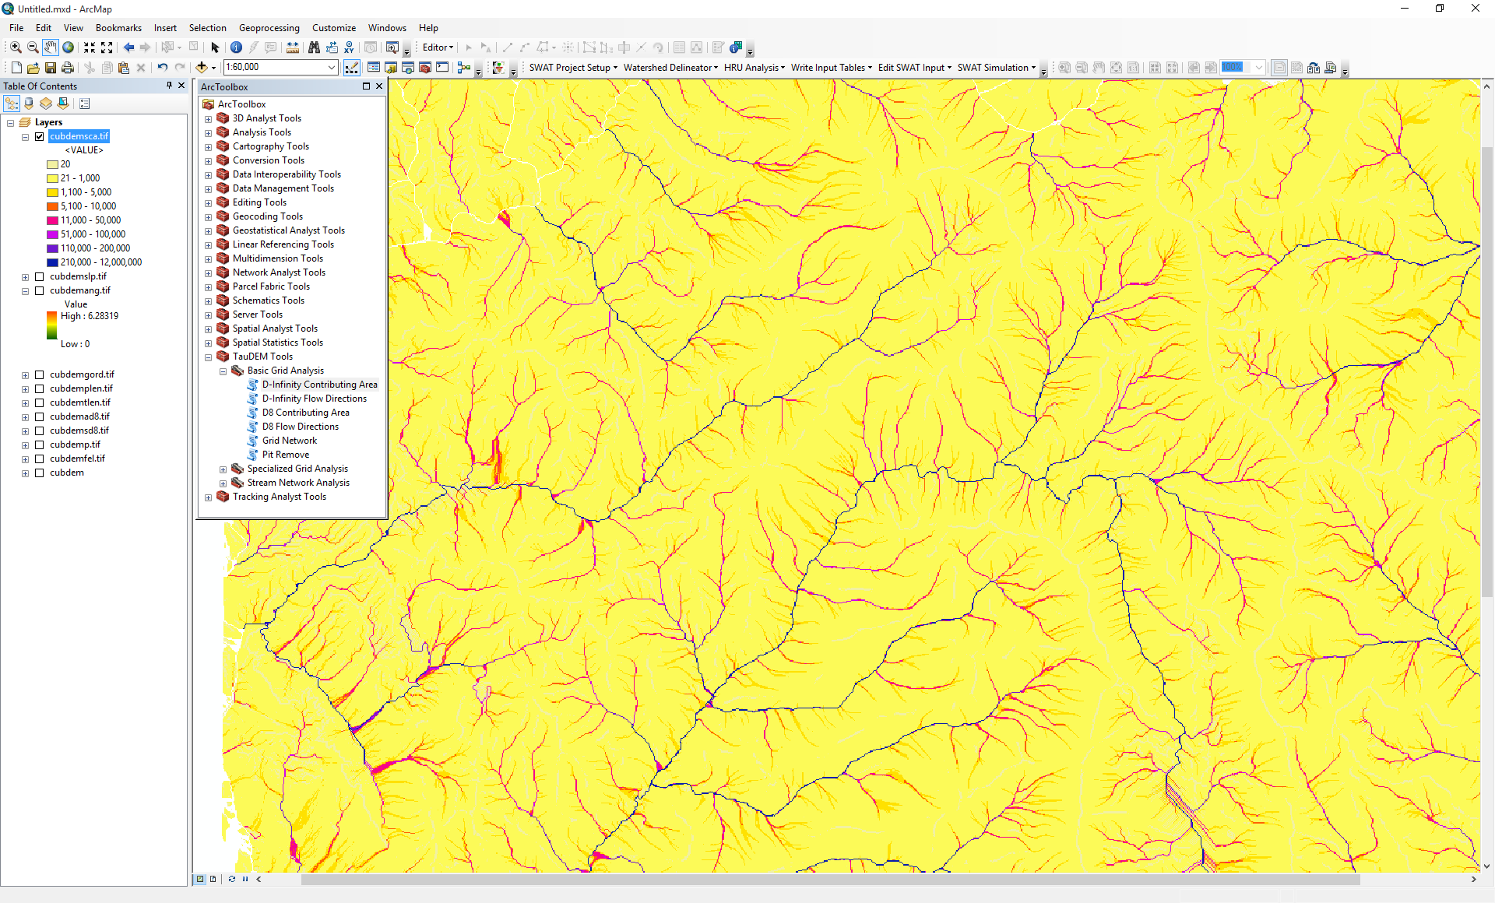

## Stream Network Analysis using TauDEM functions

TauDEM provides a number of methods for delineating and analyzing stream networks and watersheds. The simplest stream network delineation method uses a threshold on contributing area.

1. **Stream Definition by Threshold.** This function defines a stream raster grid (src suffix) by applying a threshold to the input. In this case the input is a D8 contributing area grid and a threshold of 100 grid cells has been used.

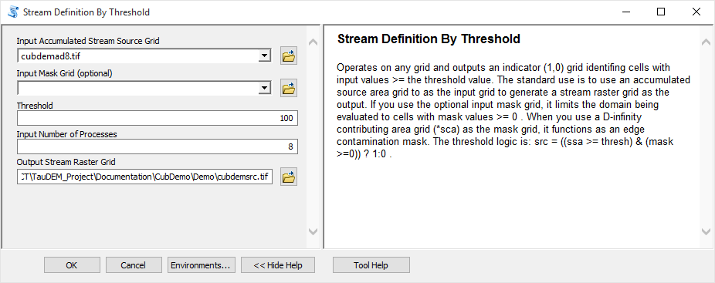

The result depicts the stream network (but is not logically connected as a network shapefile yet).

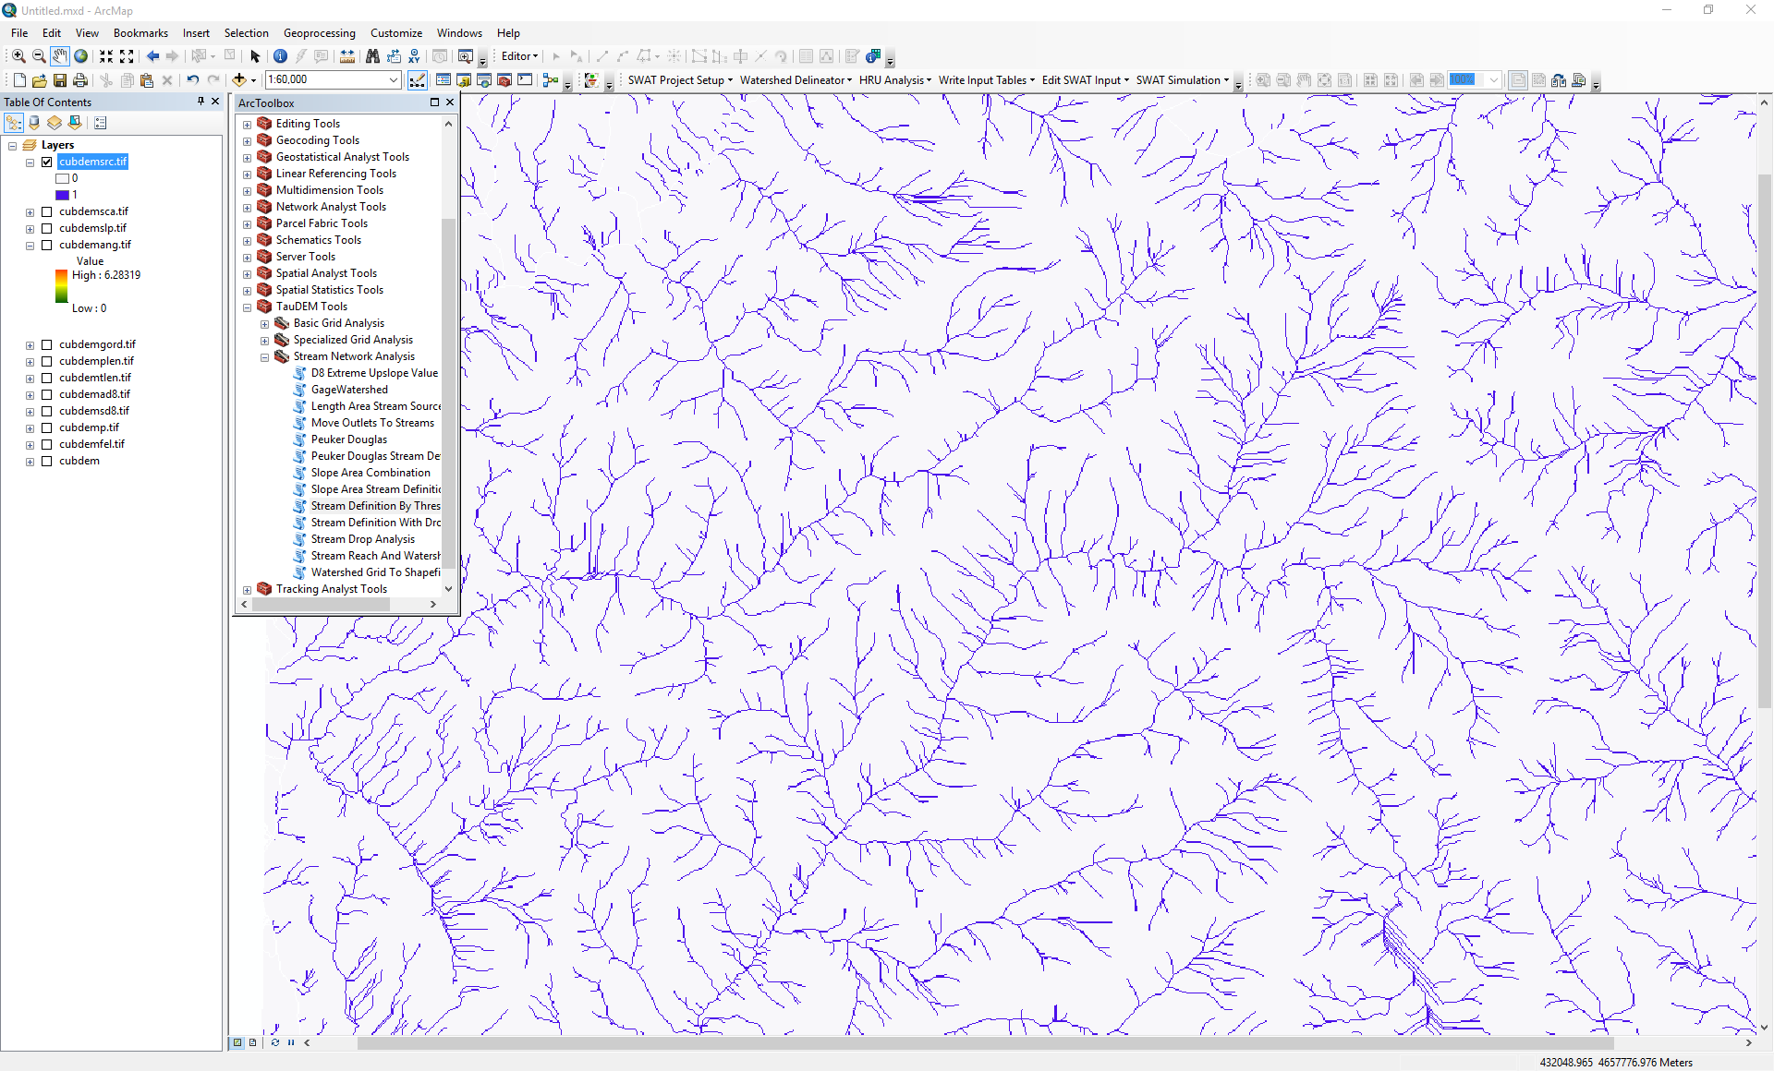

It is common to want to delineate watersheds upstream of an outlet, say a USGS stream gauge. This requires that gauge locations be precisely located on streams as rendered from the DEM. Due to inaccuracies in gauge locations and DEM stream delineation it is common for gauge locations not to be precisely on streams delineated from the DEM. The move Outlets to streams function slides gauge locations downslope following D8 flow directions until a stream (as defined by a stream raster grid) is encountered. The shapefile CubGauge in the example data is used to illustrate this.

1. Add the **CubGauge.shp** file to ArcMap and zoom in to the area around it.

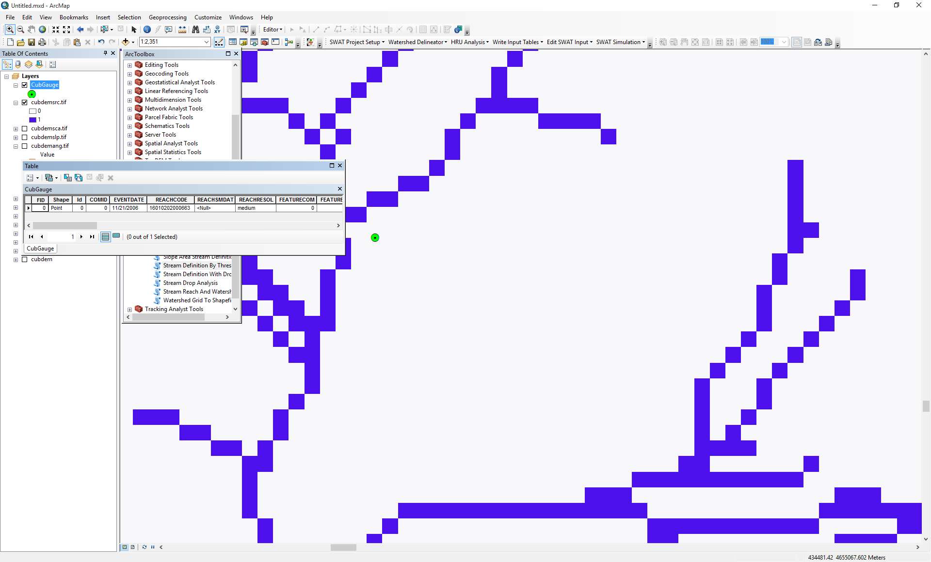

1. Open **Move Outlets to Streams** and select the following input and click OK

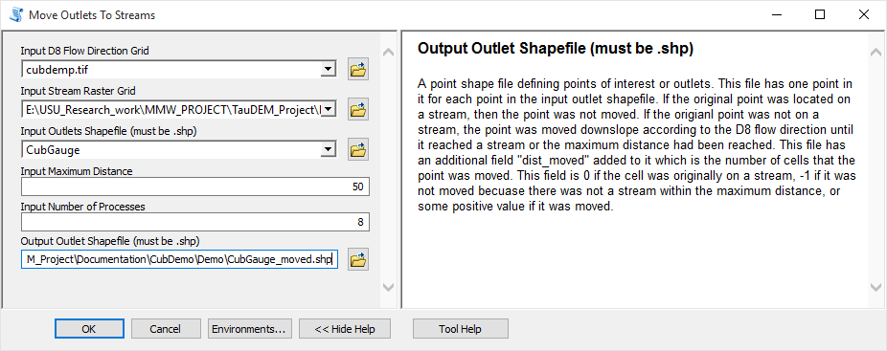

Notice (below) how the outlet has been moved to coincide with the stream.

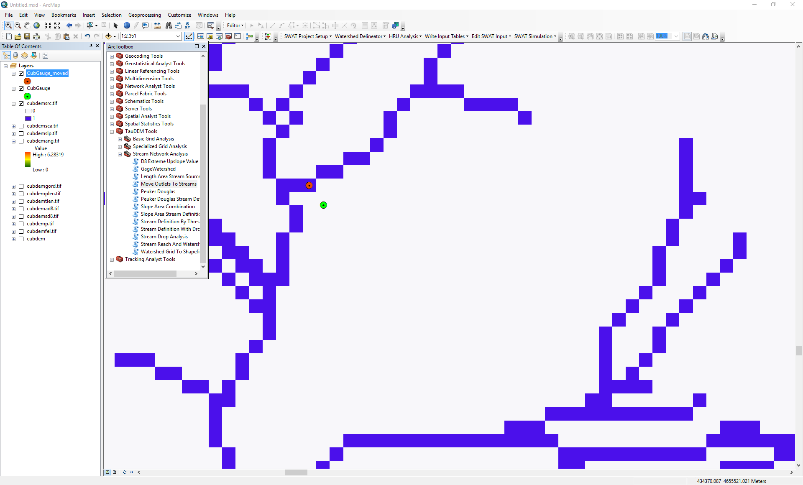

It is somewhat overkill to use 8 processors to move one outlet point, but this is illustrative of how this could be used for many more points. Upon adding the moved outlet you may have received an ArcMAP unknown spatial reference warning. Be aware in using TauDEM that TauDEM does not do any spatial reference (projection) conversions. Therefore all data needs to be in the same spatial reference system. TauDEM does copy the spatial reference information from input grids to output grids, but does not do this for shapefiles.

With the outlet positioned on the stream the stream network upstream of the outlet can be delineated.

1. Open **D8 Contributing Area** and select the following inputs and click OK

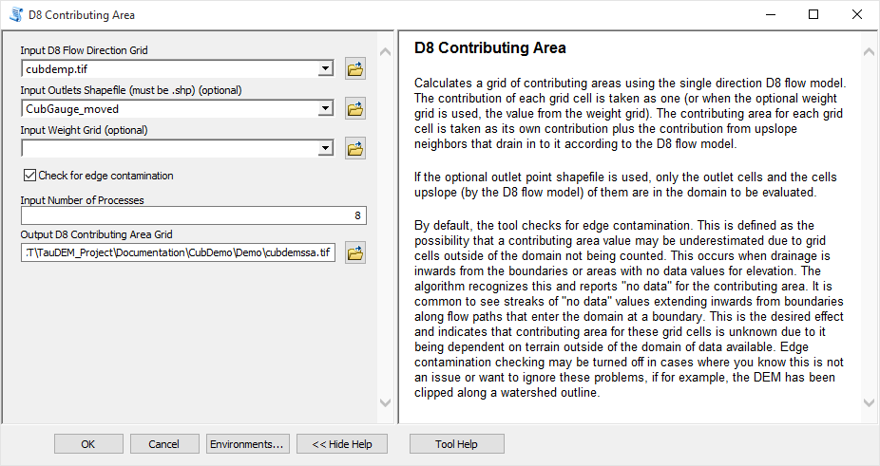

The result is contributing area only for the watershed upstream of the outlet.

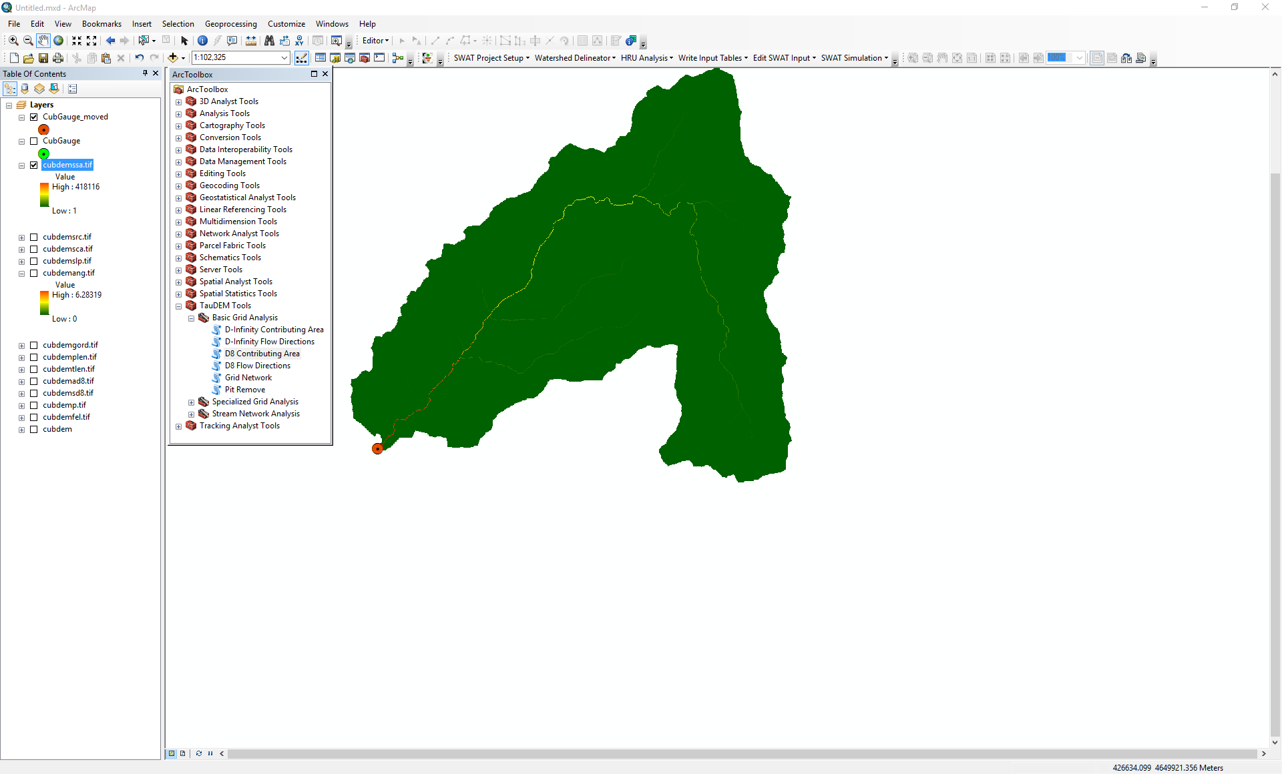

1. Open **Stream Definition By Threshold** and select the following inputs and click OK to define a stream raster for this area upstream of the outlet

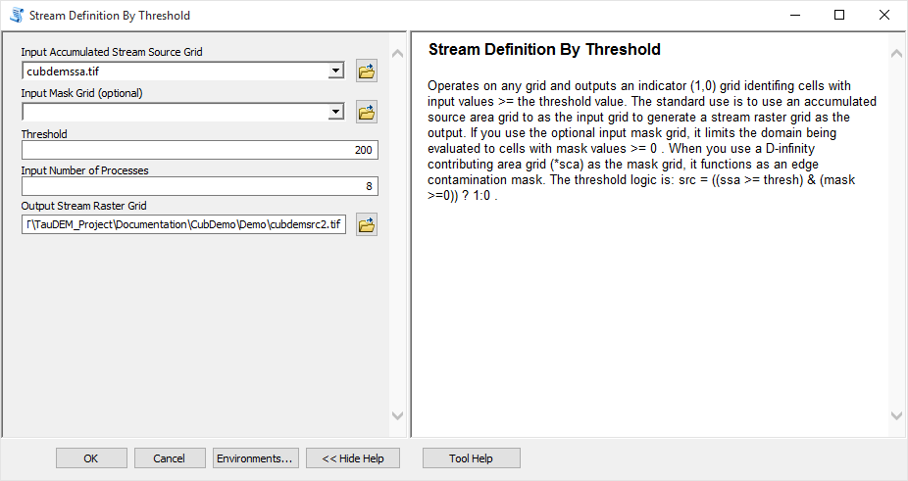

1. Open **Stream Reach and Watershed** and select the following inputs and click OK

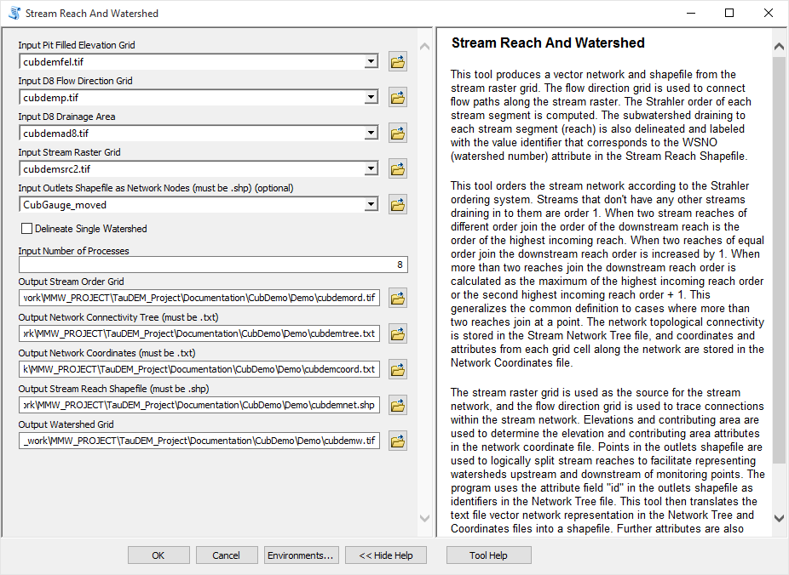

The result is a number of outputs illustrated below. These include a shapefile of the stream network and subwatersheds draining to each link of the stream network shapefile. This is one a key output from TauDEM. Each link in the stream network has a unique identifier that is linked to downstream and upstream links. Each subwatershed also has a unique identifier that is referenced in terms of the stream network that it drains to. This information enables construction of a subwatershed based distributed hydrologic model with flow from subwatersheds being connected to, accumulated in, and routed along the appropriate stream reaches.

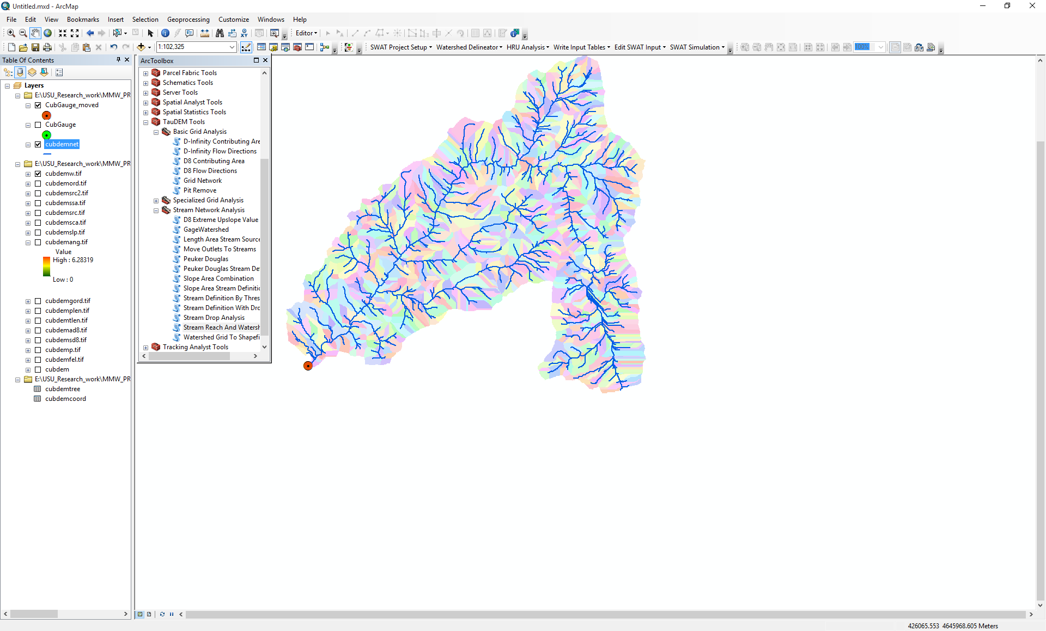

An important question in stream network delineation is what stream delineation threshold to use. The above used arbitrary thresholds of 100 and 200 grid cells. TauDEM also provides ways to do select stream delineation threshold objectively using a stream drop test following theory described in Tarboton et al. (Tarboton et al., 1991; 1992) and Tarboton and Ames (2001). This may be combined with more geomorphologically based methods for channel definition that attempt to capture topographic texture and spatial variability in drainage density. These will be illustrated next.

1. Open the **Peuker Douglas** function and select the following inputs and click OK.

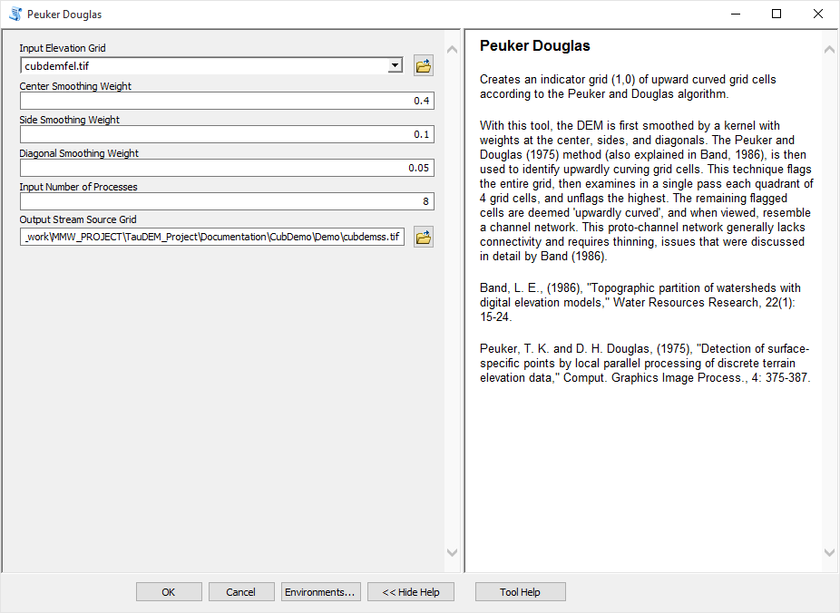

The result, derived entirely from a local filter applied to the topography is a skeleton of a stream network illustrated below

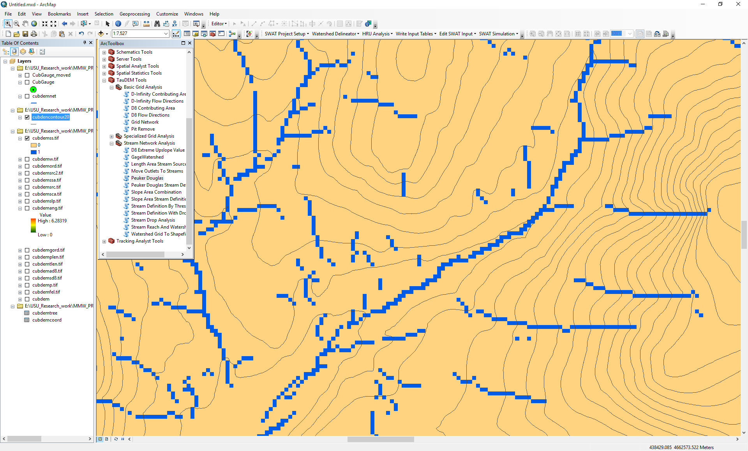

1. Open the **Peuker Douglas Stream Definition** function and select the following inputs and click OK.

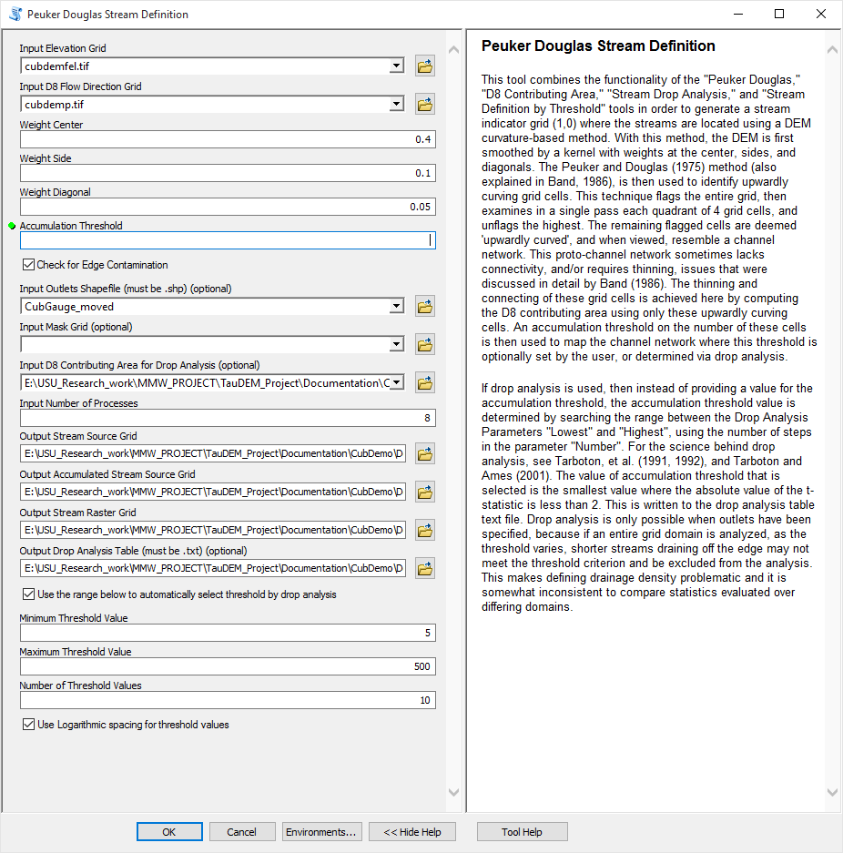

This rather extensive set of inputs configures TauDEM to run Peuker Douglas, then use the Peuker Douglas stream skeleton as a weighted input to a D8 contributing area calculation. The result is then thresholded using a range of thresholds (the drop analysis thresholds at the bottom of the input) to identify the smallest threshold for which the mean stream drop of first order streams is not significantly different from the mean stream drop of higher order streams. This is the constant drop law (Broscoe, 1959), and TauDEM uses it here to identify the highest resolution stream network that complies with this law as an objective way of identifying the stream delineation threshold. The output results include a table that reports the stream drop statistics for each threshold examined. This is included in the completion dialog below as well as written to the drop analysis table file. The last column of this gives T statistics for the differences of first and higher order streams. Using a threshold of |2| as indicating significance in this T test the threshold of 39 is chosen in this case as the objective stream delineation threshold.

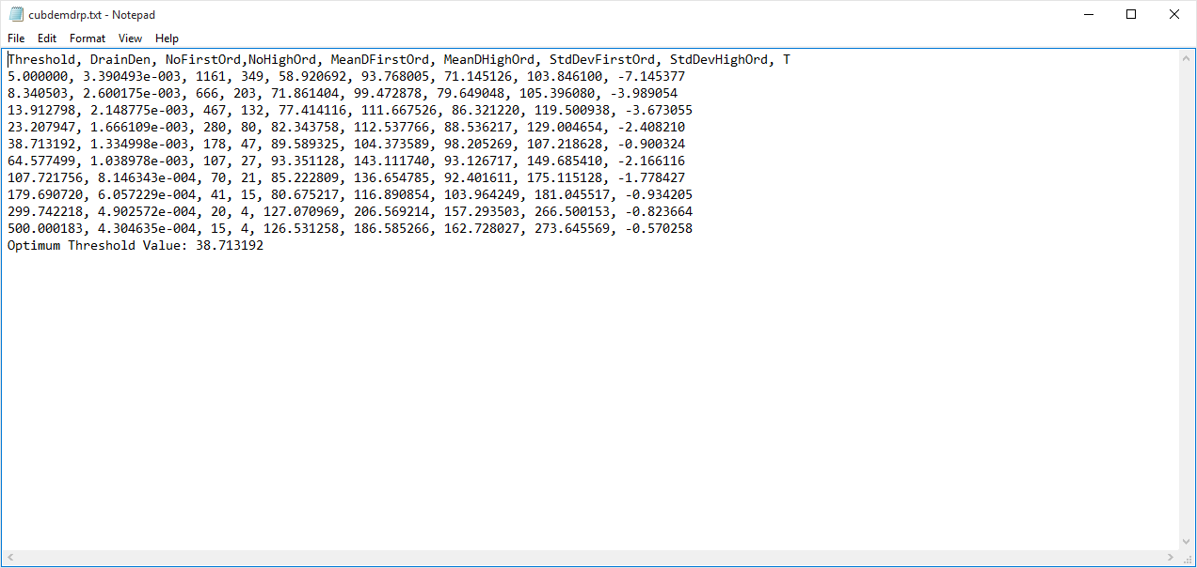

1. Open the **Stream Reach and Watershed** function and select the following inputs and click OK.

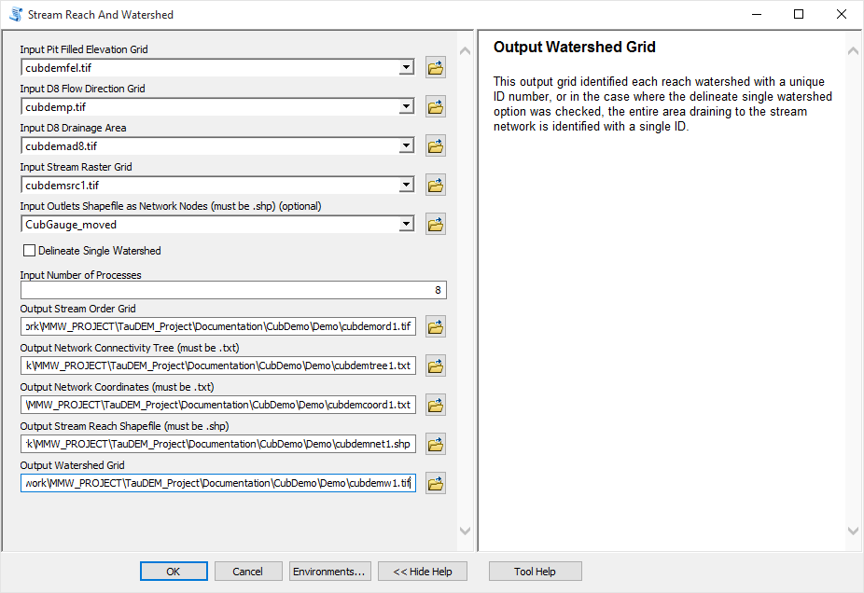

Following is an illustration of the result. Notice how the stream network has been delineated more or less consistently with the contour crenulations depicting the texture of the topography

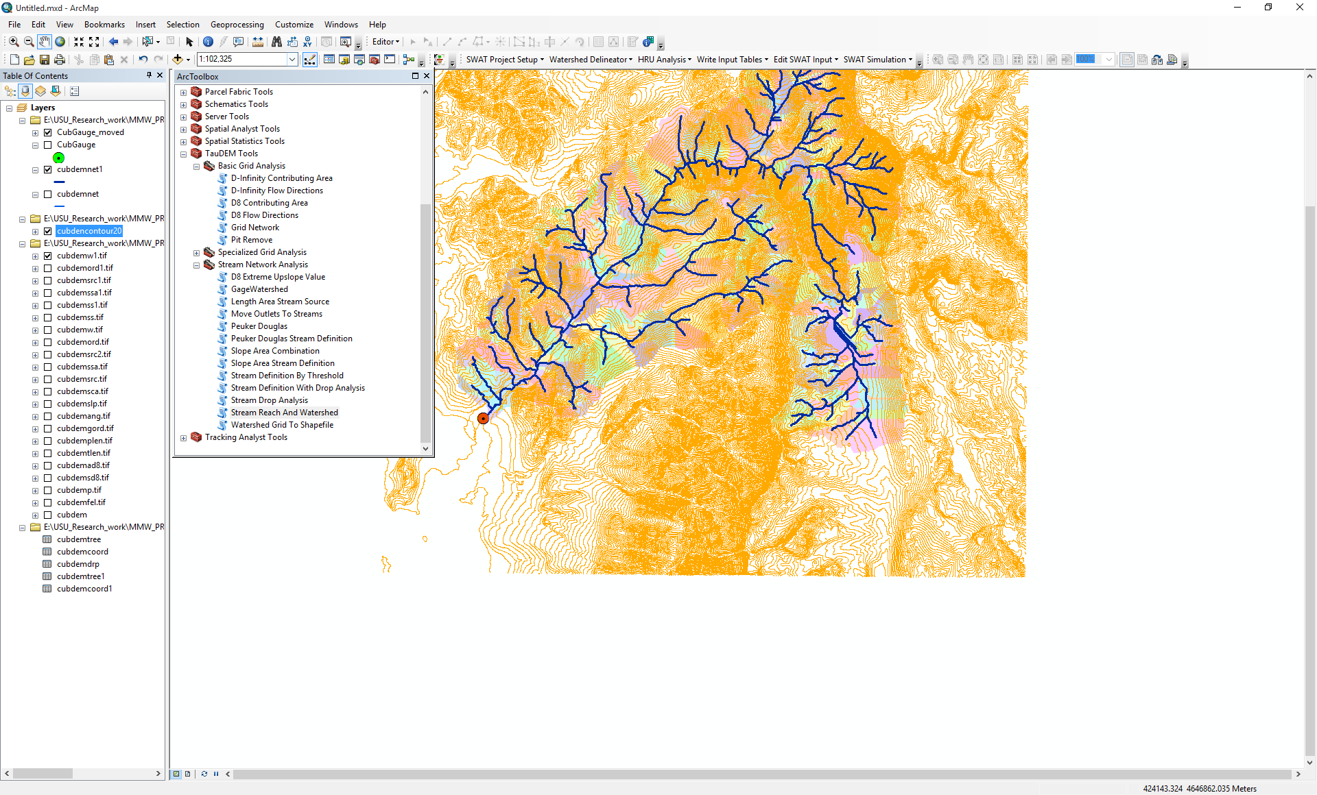

## Specialized Grid Analysis using TauDEM functions

TauDEM also includes a number of specialized grid analysis functions. Only a few are illustrated here as they are all detailed in the system help.

1. Open the **D-Infinity Distance Down** function and select the following inputs and click OK

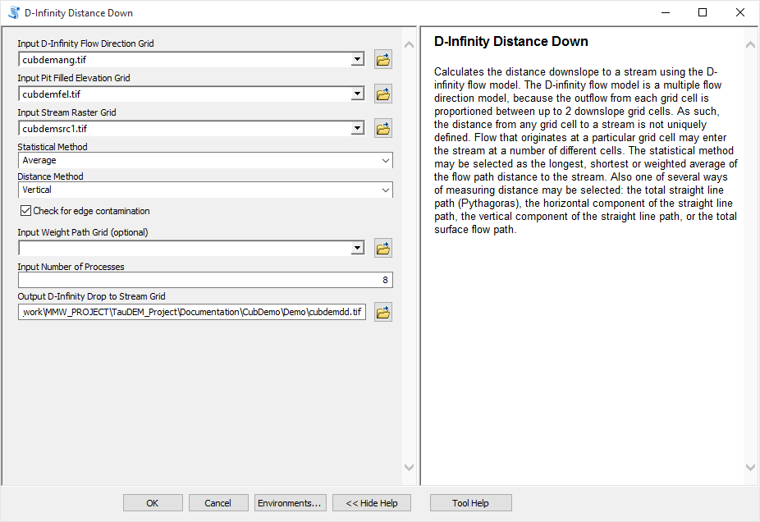

By selecting Vertical as the distance method the result is the vertical drop from each point, to a point on the stream as illustrated below

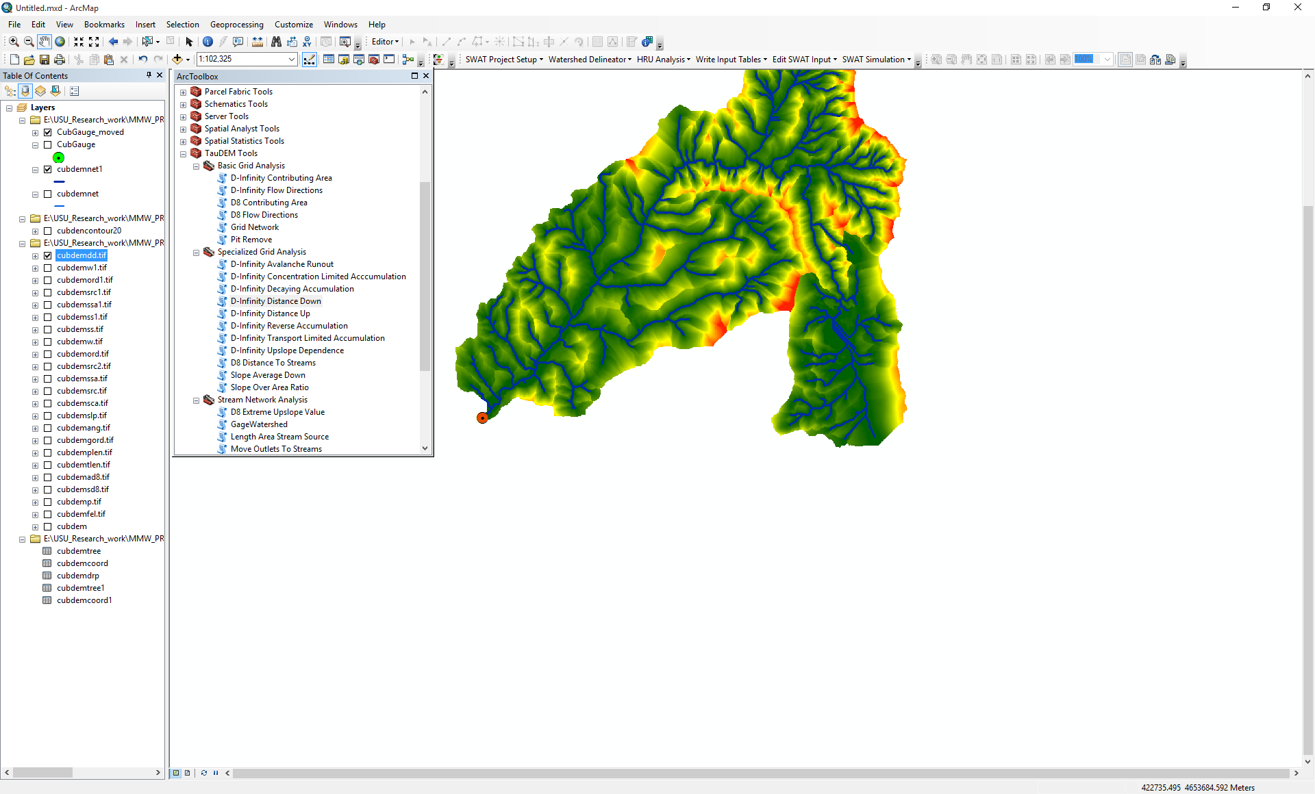

1. Open the **D-Infinity Distance Up** function and select the following inputs and click OK

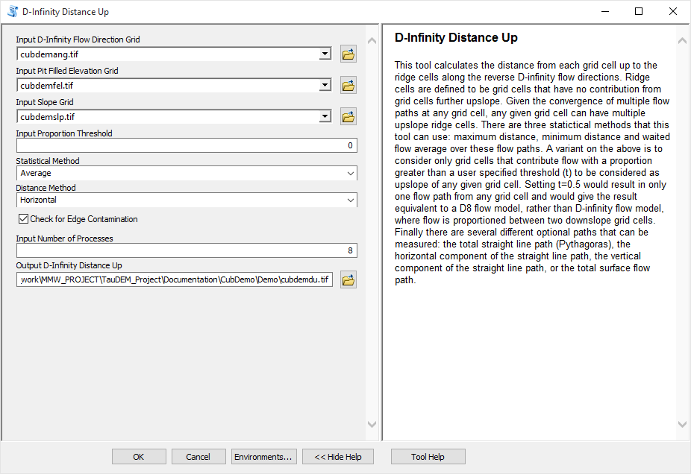

The result in this case is the average horizontal distance moving upslope along D-Infinity flow directions to a ridge, defined as a grid cell that has no other grid cells flowing in to it.

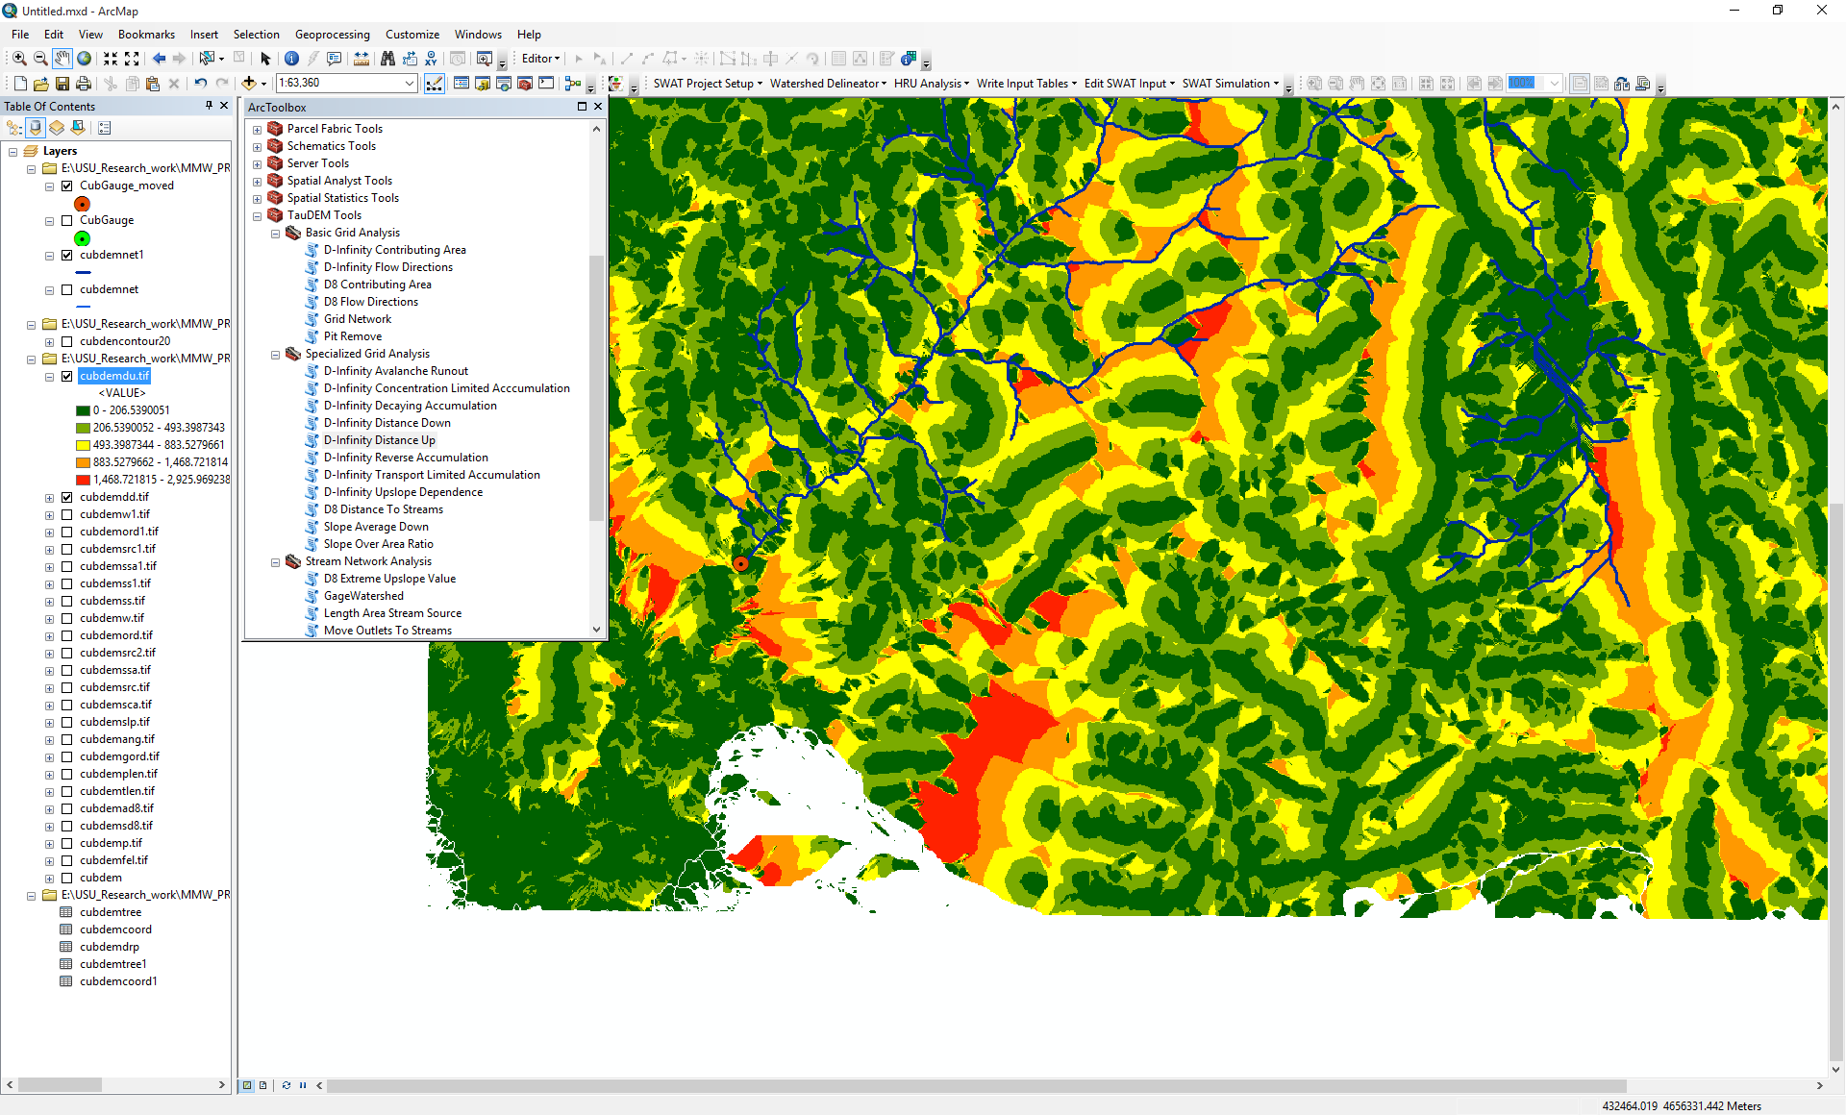

## Basic Grid Analysis using TauDEM functions for Geographic data:

1. Download the Eno River example data file from the Documentation page in [http://hydrology.usu.edu/taudem](http://hydrology.usu.edu/taudem/taudem5). Unzip the folder and load enogeo.tif into ArcMAP.

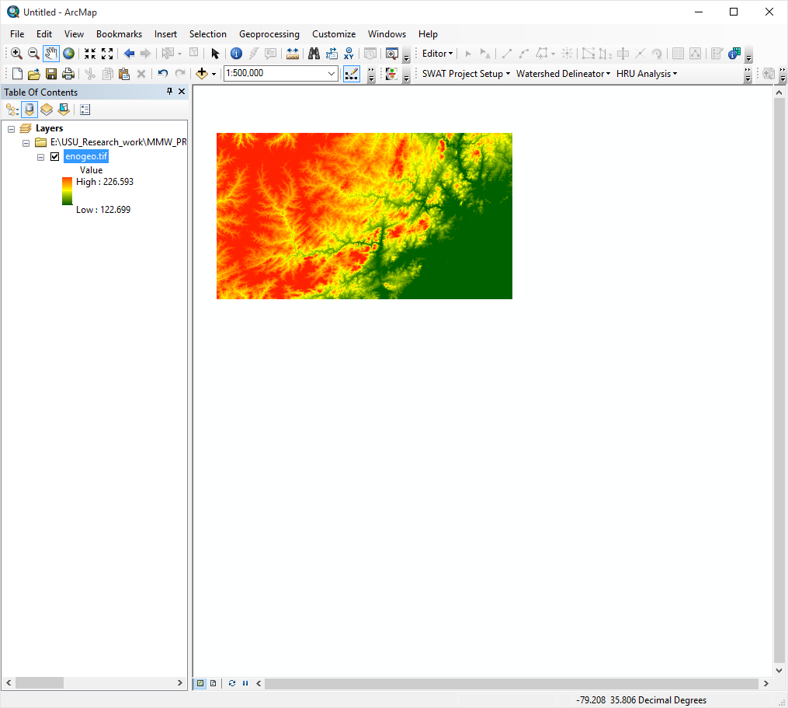

Click on the layer properties of enogeo.tif which shows that data is in the geographic coordinate system.

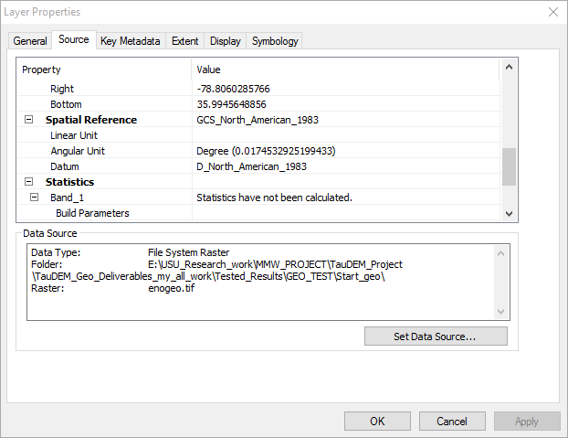

1. TauDEM 5.3 supports both geographic and projected coordinate data. Open the **PitRemove** function and select the following inputs and click OK

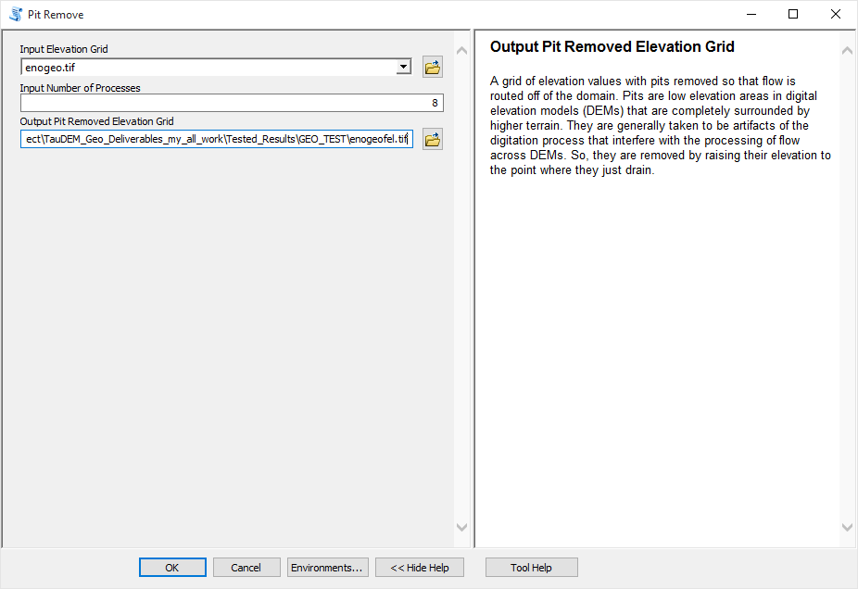

Click on the layer properties of enogeofel.tif which shows that it is also in the geographic coordinate system.

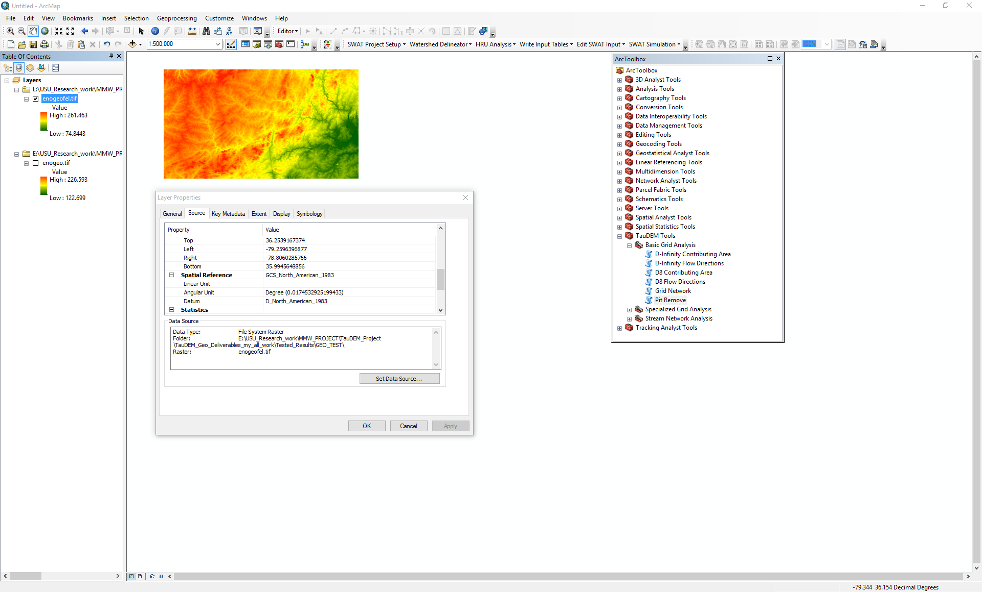

1. Open the **D8flow direction** function and select the following inputs and click OK.

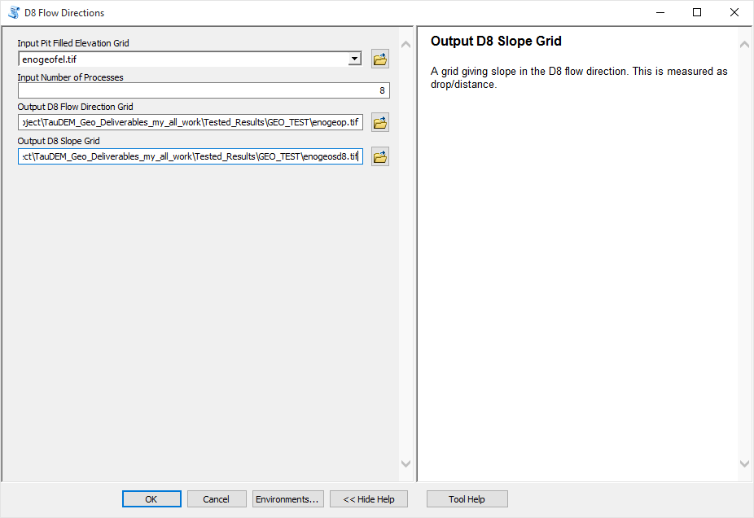

The resulting D8 flow direction grid (grid has suffix p) is illustrated which is also in geographic coordinate system.

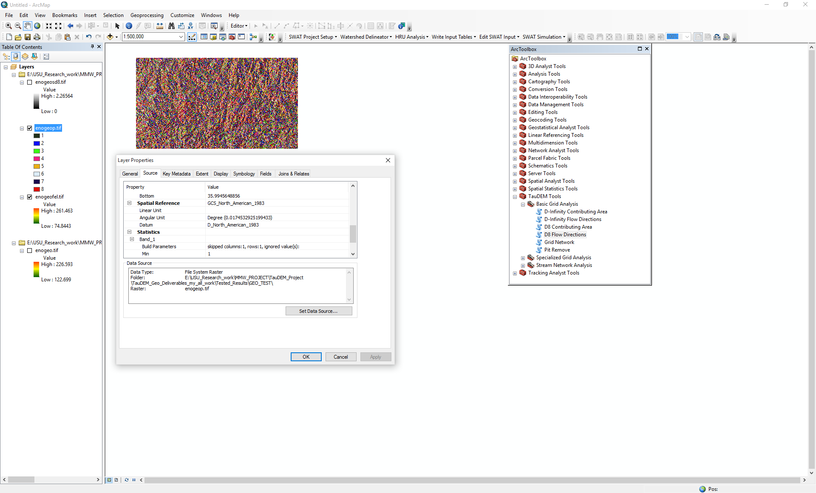

Similarly, other TauDEM functions can be applied for the geographic coordinate system data.

## References

Broscoe, A. J., (1959), "Quantitative analysis of longitudinal stream profiles of small watersheds," Office of Naval Research, Project NR 389-042, Technical Report No. 18, Department of Geology, Columbia University, New York.

Tarboton, D. G. and D. P. Ames, (2001), "Advances in the mapping of flow networks from digital elevation data," World Water and Environmental Resources Congress, Orlando, Florida, May 20-24, ASCE, <http://www.engineering.usu.edu/dtarb/asce2001.pdf>.

Tarboton, D. G., R. L. Bras and I. Rodriguez-Iturbe, (1991), "On the Extraction of Channel Networks from Digital Elevation Data," Hydrologic Processes, 5(1): 81-100.

Tarboton, D. G., R. L. Bras and I. Rodriguez-Iturbe, (1992), "A Physical Basis for Drainage Density," Geomorphology, 5(1/2): 59-76.